August 2019
IT’S TIME
To Invest In Your Neighborhood

Shepherd Park Plaza Civic Club
Annual Membership Dues & Constable Patrol Program
Pay via mail or at www.ShepherdParkPlaza.com

Enclosed is the 2020 statement for our Civic Club dues and Deputy Constable Program, which runs from September 1, 2019 thru August 31, 2020. Civic Club Dues are still a bargain at $25 per year and The Deputy Constable Program is a recommended contribution of $295 per year. Your prompt reply assures a renewed Deputy Constable contract with Harris County. The annual contract must be signed and executed by December 2019.

FOR ONLY $0.88 PER DAY

- Get active Harris County Deputy Constable Patrollers, working to lower crime rates!
  - 80 hours of patrolling a week, shared with Candlelight Plaza, every week of the year!
  - Safety Checks, Vacation Watch, and First Responses for home alarms, per your request
  - Management of vehicle speed limits for protection of our children and walkers.

- Benefit from value-added volunteer programs that enhance community and property values
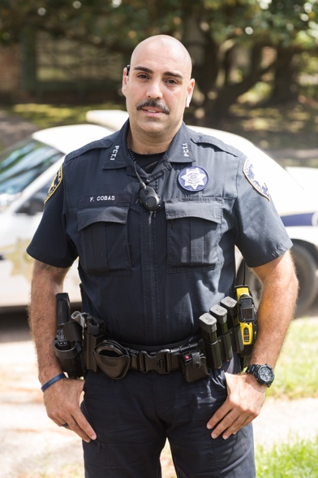
  - Citizens Patrol Program
  - Enforcement of deed restrictions and architectural controls
  - Welcoming of new neighbors

- Receive multiple forms of communication so that news of the neighborhood isn’t old news to you!
  - The Pulse, a monthly newsletter mailed to every house in SPP
  - SPP Website and email notifications
  - SPP Facebook page

- Come together through Events / Social Gatherings / Meetings
  - Oktoberfest, BBQ Cookoff, and National Night Out to name a few!

- Profit from Beautification of the Neighborhood
Deputy Cobas
  - Yard of the Month and Holiday decoration recognition
  - Flower Beds at entrances
  - Placement and flying of the US Flag on our streets for national holidays
  - Maintenance of curb painting of address numbers

For any additional information, please contact our Membership Chairman, Maureen Sullivan, 302-598-7438, membership@shepherdparkplaza.com

